**APPENDIX A**

Inform Consent Form

|  |
| --- |
| **Informed Consent Form**  This form is for students in the School of Engineering, Architecture and Information Technology in their participation to the research project entitled Web-Based Medical Record Management of Bambang National High School |
| Name of Researchers: Fabelico, Fitzfedrix E.  Olpindo, Brent Joshua A. |
| Organizational Affiliation: Saint Mary’s University School of Engineering, Architecture and Information Technology  Department of Information Technology  **Information Sheet** |
| You are being invited by student researchers from Saint Mary’s University to participate in their study on the development of a Web Based Medical Record System of Bambang National High School. You can take your time to decide whether to participate or not and you can ask questions any time for any word or concept in this form that you may not understand. |
| The purpose of this study is to develop a Web Based Medical Record System of Bambang National High School to enhance the existing processes and practices of the school clinic. |
| This study involves the use of direct interview that respondents will answer in-person. You are selected as participant because you are part of the school of Bambang National High School. You are one among the 3 selected clinic staff of Bambang National High School. Please be informed that your participation is voluntary, and you can withdraw any time without explanation. Your non-participation or withdrawal will not affect your reputation as a student or faculty of the school. |
|
|
|
| Should you choose to participate in the study, you shall be participating in an interview. |
| It is estimated that your participation in the study will only take not more than 15 minutes. |
| There is no known risk in your participation to the study.  However, you will be contributing to the development of the system as a result of this study and this may be beneficial to The School Clinic of Bambang National High School. |
| You shall not receive any payment for your participation nor any reimbursements. Even if you have chosen to participate voluntarily, you have the right to refuse to continue and any information you have already provided will not be used in the study. Rest assured that your privacy will be respected, and all your answers will be treated with utmost confidentiality. |
|
|
| The results of this study may be disseminated within Saint Mary’s University through student research form. Also, the study may be submitted for publication in national or international journals. For any matter concerning this study, you can contact Drix Fabelico through the following mobile number: 09533005300 or email: drixzfabelico@gmail.com |
| This study is approved by the Saint Mary’s University Research Ethics Board (SMUREB) at Saint Mary’s University, Ponce Street, DMM, Bayombong, Nueva Vizcaya with cellphone number: 09177053041 and email: [reb@smu.edu.ph](mailto:reb@smu.edu.ph).  **Certificate of Consent** |
| I have read the foregoing information, or it has been read to me. I have had the opportunity to ask questions about it and any questions I have asked have been answered to my satisfaction. I consent voluntarily to be a participant in this study.  Print Name of Participant: ___________________  Signature of Participant: ________________________  Date: |
| I have accurately read out the information sheet to the potential participant, and to the best of my ability made sure that the participant understands that the following will be done:   * I agree to participate in the study * I disagree to participate in the study   I confirm that the participant has been given the opportunity to ask questions and all his/her queries have been answered correctly to the best of my ability. I confirm that the individual has not been coerced into giving consent, and the consent has been given freely and voluntarily.  NAME and SIGNATURE______________________  DATE______________________ |

**APPENDIX B**

Interview Questionnaire

**DETAILED INTERVIEW**

**Demographics/Profile of School Nurse/Heath Worker**

1. Name: (What is your name?) __________________
2. Age: (How old are you?) ______________________
3. Length of Service: (How long have you been working in BNHS?) _______________
4. Job Description: (What is/are your functions and responsibilities in this school?) _______________________________________________________________________________________________________________________________________________________________________________________________________________

**Existing Practices and Process of School Clinic**

1. What are the existing practices and processes of the school clinic? ____________________________________________________________________________________________________________________________________________________________________________________________________________________________________________________________________________________
2. Are the students required to register or have their own clinic medical record when they enroll? _________________________________________________________________________________________________________________________________________________________________________________________________________________
3. Where are you keeping the medical records? How do you manage these medical records? _______________________________________________________________________________________________________________________________________________________________________________________________________________
4. How do you update the check-up records of your patients? _______________________________________________________________________________________________________________________________________________________________________________________________________________
5. How do your record and update the nutritional status and deworming records of your patients? _______________________________________________________________________________________________________________________________________________________________________________________________________________
6. How do you update the check-up records of your patients? _______________________________________________________________________________________________________________________________________________________________________________________________________________
7. How do you schedule appointments and check-up of your patients? _______________________________________________________________________________________________________________________________________________________________________________________________________________
8. How do you generate or produce patient’s reports to be submitted to the School Principal or to any concerned end-user? _______________________________________________________________________________________________________________________________________________________________________________________________________________
9. What practices are done in disposing of your medical records? How long do you keep your medical records? ______________________________________________________________________________________________________________________________________________________________________________________________________________________________________________________________________________________
10. What happen if emergency occurred? What are the practices done? _______________________________________________________________________________________________________________________________________________________________________________________________________________
11. Do the school use or have a LAN connection? What offices use these LAN? Who is the administrator of this LAN? ______________________________________________________________________________________________________________________________________________________________________________________________________________

**Problems and Challenges Encountered in the Existing Practices and Processes in the School Clinic**

1. What are the problems and challenges encountered in the existing practices and processes of the school clinic? ____________________________________________________________________________________________________________________________________________________________________________________________________________________________________________________________________________________
2. What are the problems or challenges that you experience in recording the medical information of your patients? How did you manage to solve this problem? ________________________________________________________________________________________________________________________________________________________________________________________________________________
3. What are the problems or challenges that you experience in updating the check-up records of your patients? How did you manage to solve this problem? ________________________________________________________________________________________________________________________________________________________________________________________________________________
4. What are the problems or challenges that you experience in recording and updating the nutritional status and deworming records of your patients? How did you manage to solve this problem? ____________________________________________________________________________________________________________________________________________________________________________________________________________
5. What are the problems or challenges that you experience in updating the check-up records of your patients? How did you manage to solve this problem? _________________________________________________________________________________________________________________________________________________________________________________________________________________
6. What are the problems or challenges that you experience in scheduling appointments and check-up of your patients? How did you manage to solve this problem? _________________________________________________________________________________________________________________________________________________________________________________________________________________
7. What are the problems or challenges that you experience in generating or producing patient’s reports to be submitted to the School Principal or to any concerned end-user? How did you manage to solve this problem? _________________________________________________________________________________________________________________________________________________________________________________________________________________

**Proposal for the Development of Web-based Medical Record Management System**

1. Do you want to improve your medical record management system? _____________________________________________________________________
2. Would you like to have a medical record management system of BNHS linked to your LAN? _____________________________________________________________________
3. What are your suggestions to improve your medical record management system in your clinic? ________________________________________________________________________________________________________________________________________________________________________________________________________________________________________________________________________________________

**APPENDIX C**

Evaluation Form

EVALUATION FORM

A ProposedWeb Based Medical Record Management System of Bambang National High School EVALUATION using ISO/IEC 25010 Software Quality Standards

*(This survey questionnaire is designed to determine the status and performance of the A Proposed* Web-Based Medical Record Management System of Bambang National High School*)*

Dear Respondent,

We are currently undertaking our Capstone Project which is A Proposed Web Based Medical Record Management System of Bambang National High School. With this, we respectfully ask for your help in giving the information requested below for assessment reasons. The information will be very helpful for us as we finish our final capstone project paper and complete the prerequisites for the Bachelor of Science in Information Technology degree.

Thank you very much.

Fabelico, Fitzfedrix E.

Olpindo, Brent Joshua A.

Please check the box that best represents your assessment on the extent of compliance to ISO 25010:2015 of the developed Web based medical record system of Bambang National High School in terms of Functionality, Efficiency, Usability, Reliability, Portability, and Maintainability and using the following scale:

5 – Outstanding or to a very great extent

4 – Very Satisfactory or to a great extent

3 – Satisfactory or to a moderate extent

2 – Fair or to a little extent

1 – Poor or to a very little extent

|  |  |  |  |  |  |
| --- | --- | --- | --- | --- | --- |
| **ISO 25010 Software Quality Standards** |  |  |  |  |  |
| 1. **Functional Suitability** | **5** | **4** | **3** | **2** | **1** |
| Functional completeness  It covers all the specified tasks and user objectives |  |  |  |  |  |
| Functional correctness  It provides the correct results with the needed degree of precision |  |  |  |  |  |
| Functional appropriateness  Facilitate the accomplishment of specified tasks and objectives |  |  |  |  |  |
| 1. **Performance Efficiency** |  |  |  |  |  |
| Time behavior  Meet the requirements in the response and processing time when performing its functions |  |  |  |  |  |
| Resource utilization  Meet the requirements in the amounts and types of resources used when performing its functions |  |  |  |  |  |
| Capacity  Meet the requirements in the maximum limits |  |  |  |  |  |
| 1. **Compatibility** | **5** | **4** | **3** | **2** | **1** |
| Co-existence  Can perform its required functions efficiently while sharing a common environment and resources |  |  |  |  |  |

|  |  |  |  |  |  |
| --- | --- | --- | --- | --- | --- |
| Interoperability  Components can exchange information and use the information that has been exchanged |  |  |  |  |  |
| 1. **Usability** | **5** | **4** | **3** | **2** | **1** |
| Appropriateness recognizability  It is appropriate to the needs of the users. |  |  |  |  |  |
| Learnability  Can be used to achieve specified goals of learning with effectiveness, efficiency, freedom from risk and satisfaction in a specified context of use |  |  |  |  |  |
| Operability  It is easy to operate and control |  |  |  |  |  |
| User error protection  Protects users against making errors |  |  |  |  |  |
| User interface aesthetics  Its interface enables pleasing and satisfying interaction for the user |  |  |  |  |  |
| Accessibility  Can be used to a widest range of characteristics and capabilities to achieve a specified goal in a specified context of use |  |  |  |  |  |
| 1. **Reliability** | **5** | **4** | **3** | **2** | **1** |
| Maturity  Meets the need for reliability under normal operation |  |  |  |  |  |
| Availability  It is operational and accessible when required for use |  |  |  |  |  |
| Fault tolerance  It operates as intended despite the presence of hardware or software faults |  |  |  |  |  |

|  |  |  |  |  |  |
| --- | --- | --- | --- | --- | --- |
| Recoverability  Can recover the data directly affected and re-establish the desired state. |  |  |  |  |  |
| 1. **Security** | **5** | **4** | **3** | **2** | **1** |
| Confidentiality  Ensures that the data are accessible only to those authorized to have access |  |  |  |  |  |
| Integrity  Prevents unauthorized access to, or modification of programs or data |  |  |  |  |  |
| Non-repudiation  Can be proven to have taken place, so that it cannot be repudiated later |  |  |  |  |  |
| Accountability  Actions of an entity can be traced uniquely to the entity |  |  |  |  |  |
| Authenticity  The identity of a subject can be proved to be the one claimed |  |  |  |  |  |
| 1. **Maintainability** | **5** | **4** | **3** | **2** | **1** |
| Modularity  Composed of discrete components such that a change to one component has minimal impact on other components |  |  |  |  |  |
| Reusability  Assets can be used in more than one system, or in building other assets |  |  |  |  |  |
| Analyzability  It is possible to assess the impact of an intended change to one or more of its parts, or to diagnose deficiencies or cause of failures |  |  |  |  |  |
| Modifiability  Can be effectively and efficiently modified without introducing defects or degrading existing product quality |  |  |  |  |  |
| Testability  Test Criteria can be established and can be performed to determine whether those criteria have been met |  |  |  |  |  |
| 1. **Portability** | **5** | **4** | **3** | **2** | **1** |
| Adaptability  Effectively and efficiently be adapted for evolving hardware, software, or other usage environments |  |  |  |  |  |
| Install ability  Can be successfully installed and/or uninstalled in a specified environment |  |  |  |  |  |
| Replaceability  Can replace another specified software product for the same purpose in the same environment. |  |  |  |  |  |

System Enhancement: Question:

What are your suggestions and comments to further enhance the proposed system?

___________________________________________________________________________________________________________________________________________________________________________________________________________________________________________________________________________________

**APPENDIX D**

Prototypes

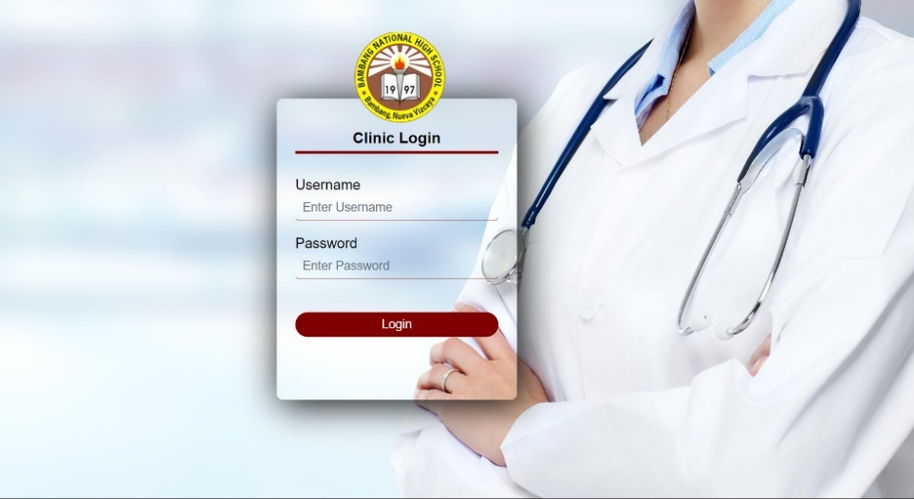

*Figure 1.* Login Page

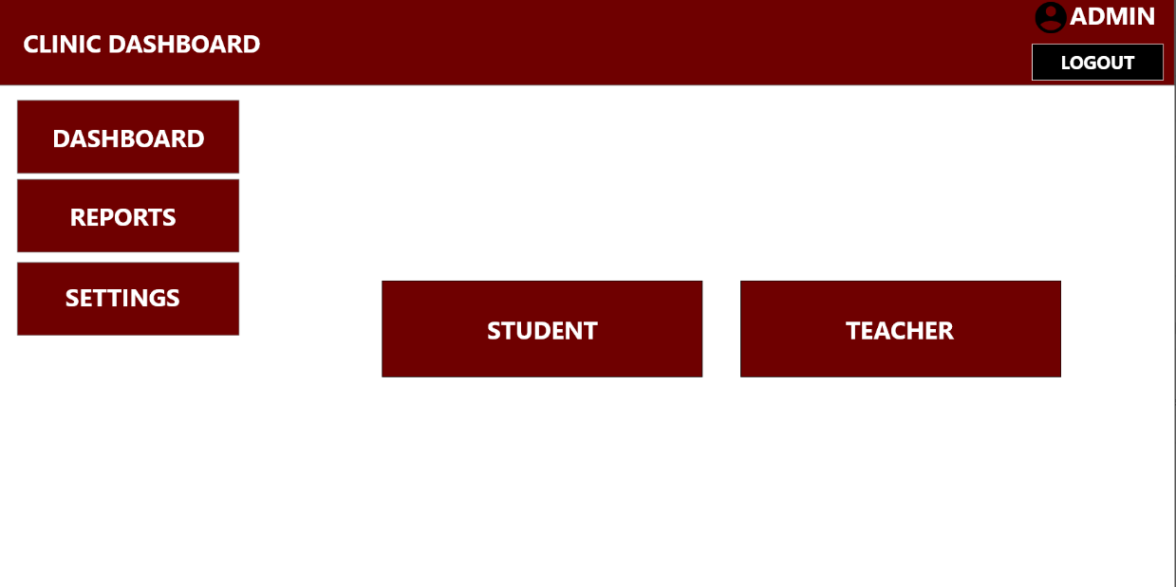

*Figure 1.1.* Clinic Dashboard

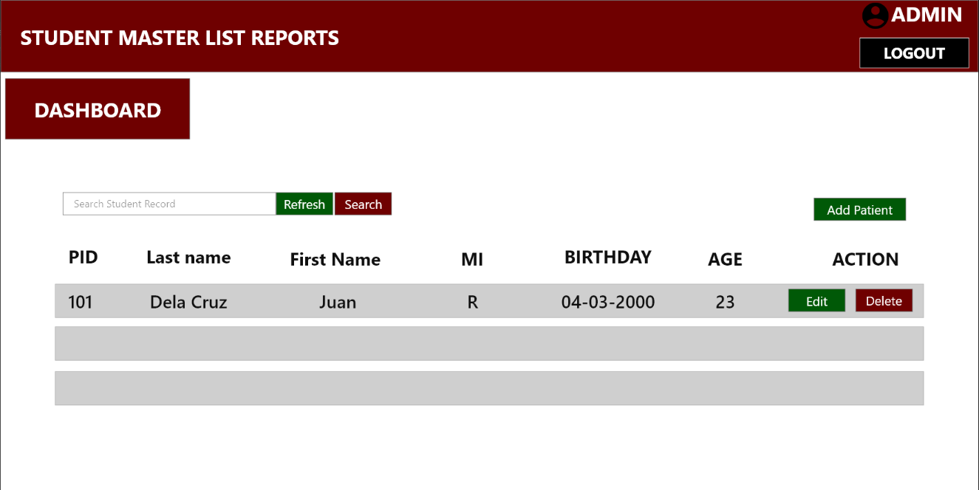

*Figure 1.3.* Reports

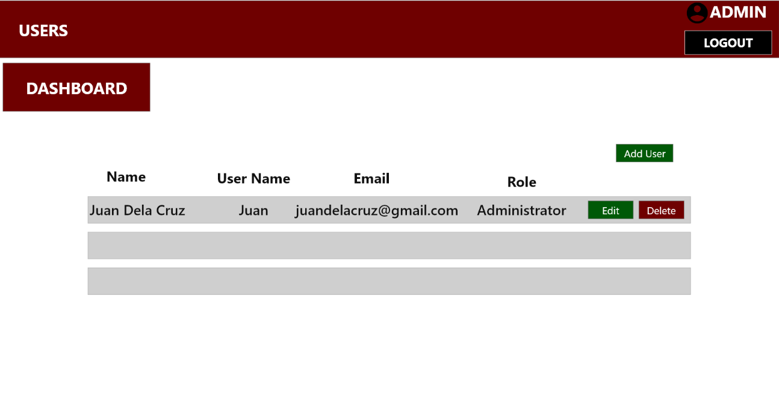

*Figure 1.4.* Users

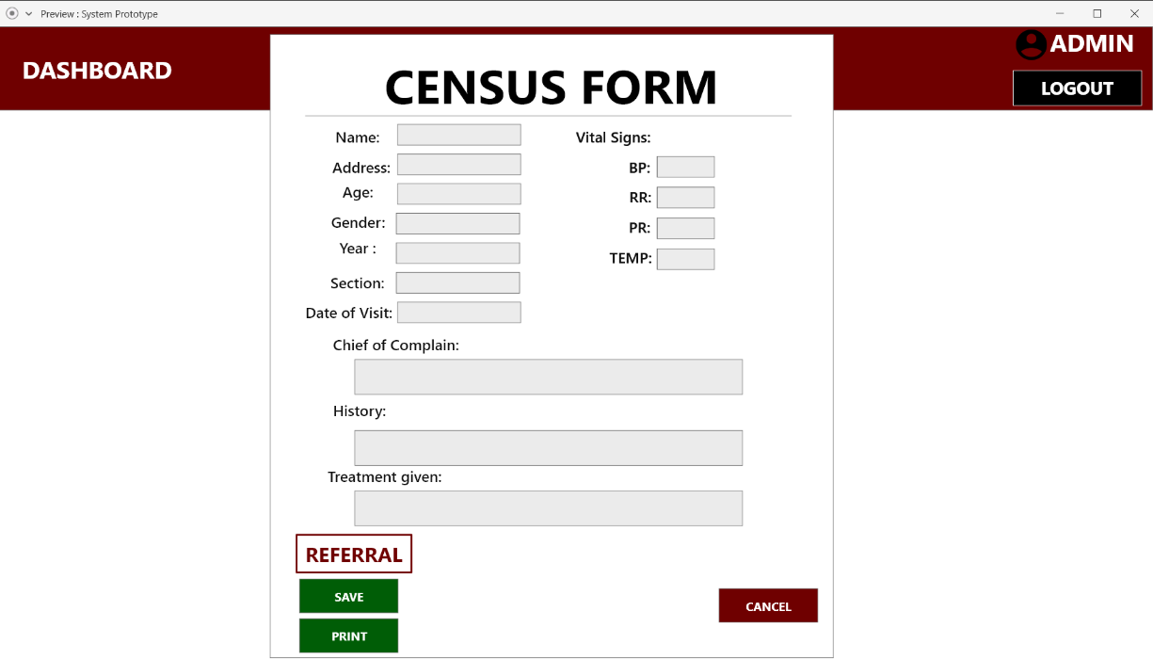

*Figure 1.5.* Medical Form

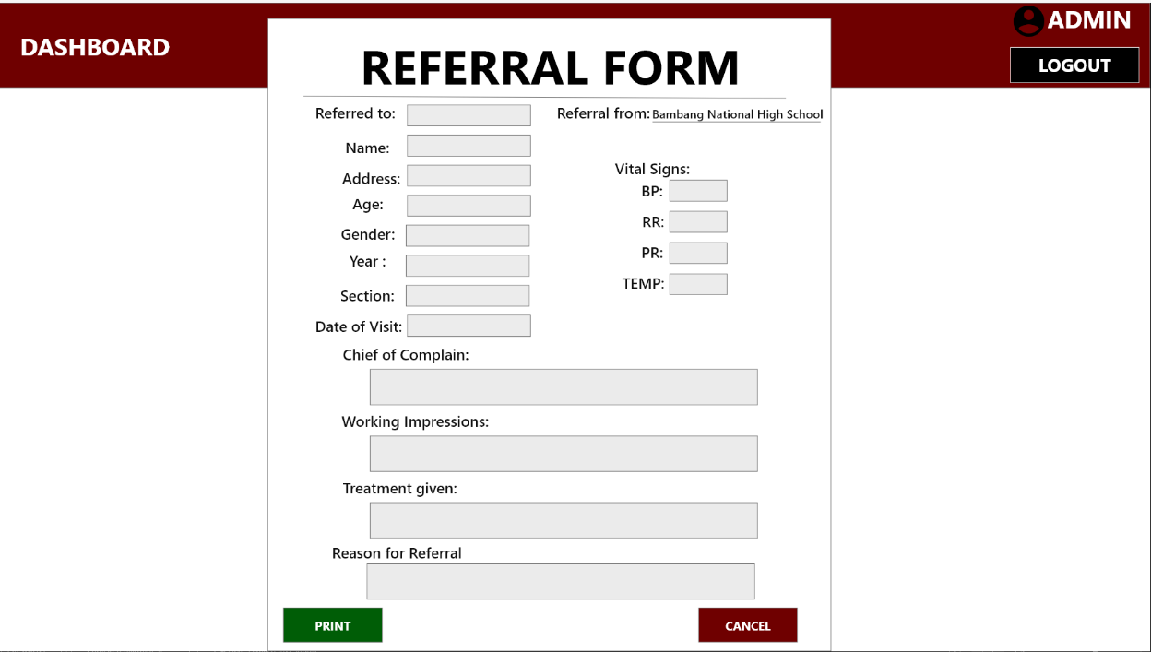

*Figure 1.6.* Referral Form

**Appendix E**

Answered Questionnaire

**Appendix F**

Database Design

**APPPENDIX G**

User Training

*Figure 2.* User Training

**Appendix H**

Observation

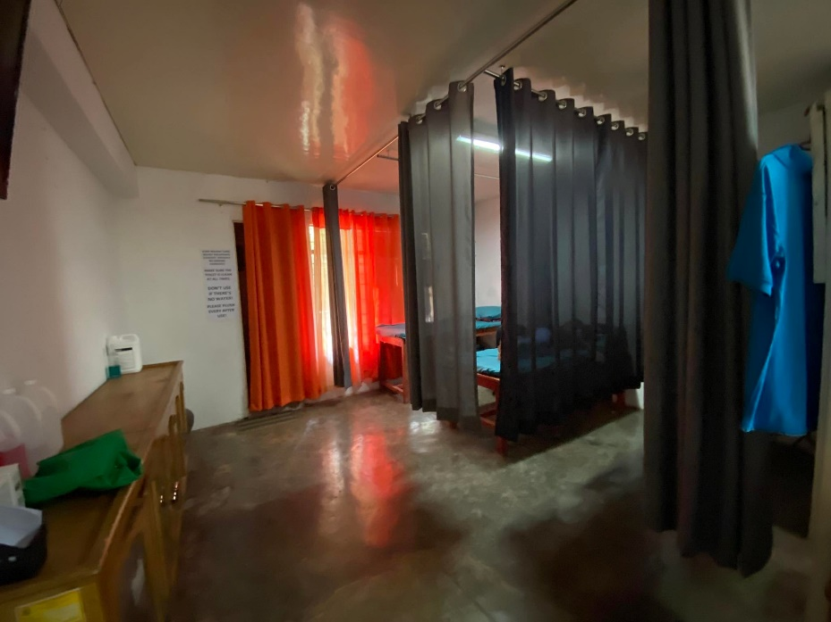

*Figure 3.* Observation

**APPENDIX I**

Interview with the School Nurse

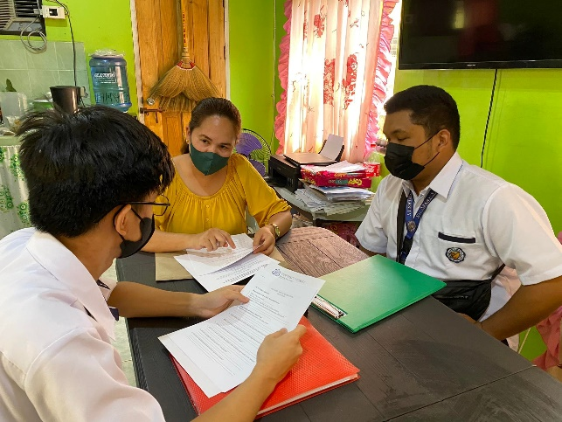

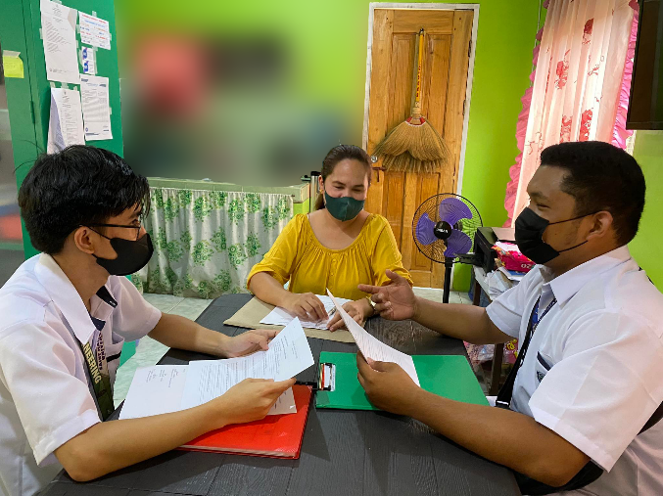

*Figure 4.* Interview with school nurse

**APPENDIX J**

Document Review



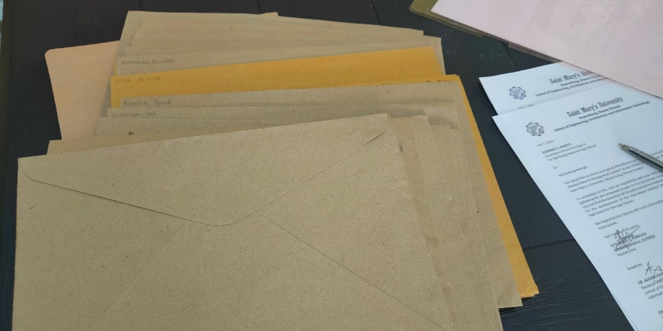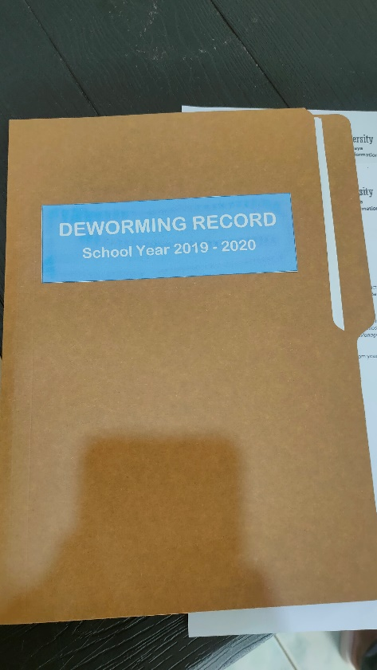

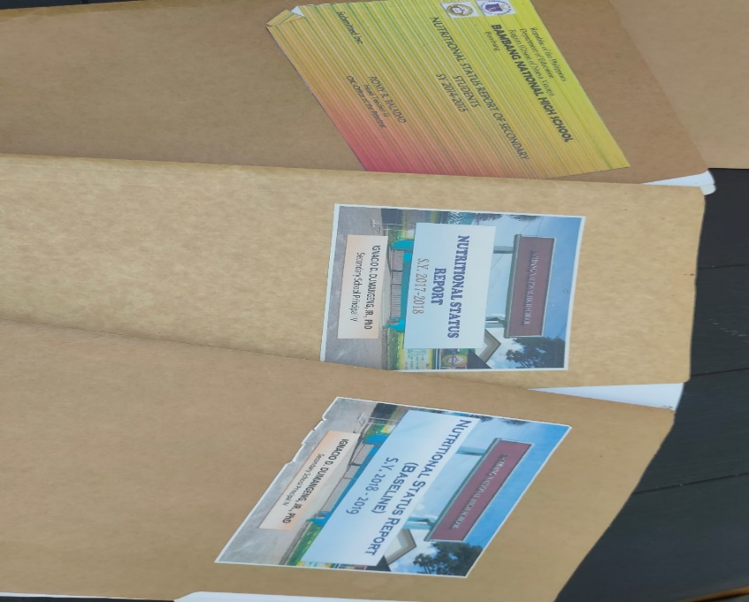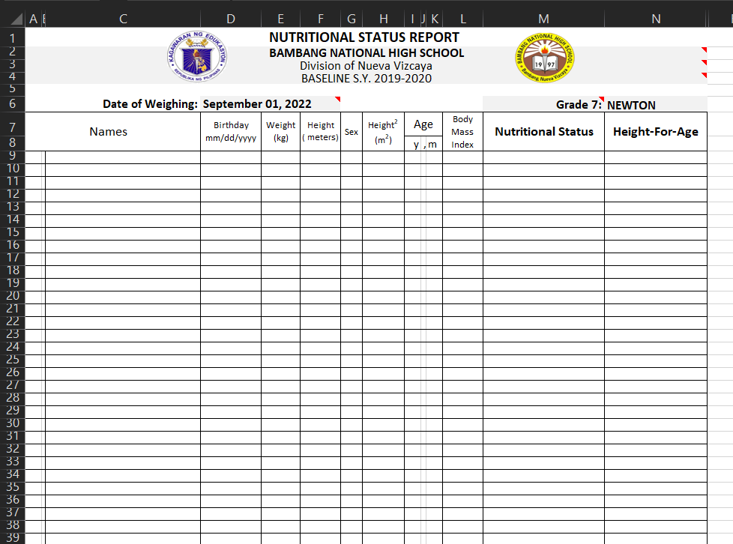

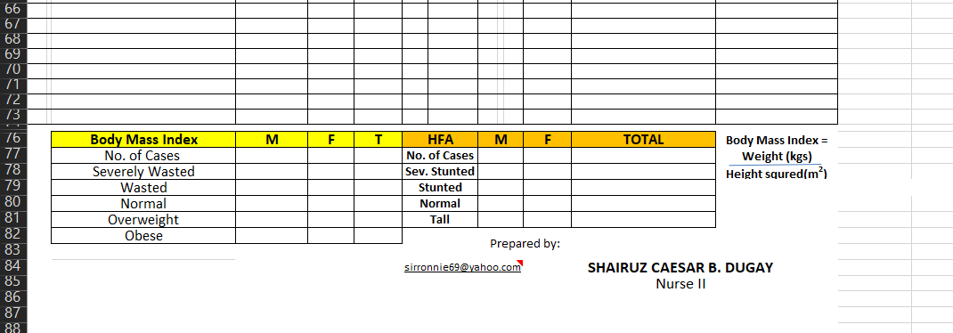

*Figure 5.* Document Review

**APPENDIX K**

Implementation Plan

**Implementation Plan**

1. **Management Overview**

The system's primary responsibility is to manage and arrange the clinic medical record system at Bambang National High School, apply the system to users accurately, and instruct users on how to use it correctly.

**Point of Contact**

|  |  |  |
| --- | --- | --- |
| **Role** | **Name** | **Contact Number** |
| Developer | Fitzfedrix Fabelico | 09533005300 |
| Brent Joshua Olpindo |  |

1. **Implementation Support**

|  |  |
| --- | --- |
| **Platform** | **Description** |
| **Desktop** | * Processor: Intel Core i3 or greater * Memory: 4GB RAM or higher * Hard Disk Space: 1TB * Monitor:14” LCD * Keyboard:101/102 Keyboard * Mouse: Microsoft USB * Printer: Epson 2100 |

1. **Hardware**
2. **Software**

|  |  |
| --- | --- |
| **Platform** | **Description** |
| **Desktop** | * Operating System: Windows 7 or greater * Database Application: MySQL (SQLyog v.10) * Software Development: Visual Studio Code |

**APPENDIX L**

Maintenance Plan

**Maintenance Plan**

**The following actions must be completed in order to keep the system's functionalities operating correctly:**

* The payment of the hosting shall be accomplished yearly.
* To check if the server is up.
* To check if the administrator has an internet connection.

**APPENDIX O**

User Manual

**Web Application**

1. **How to login (Admin and Nurse users)**

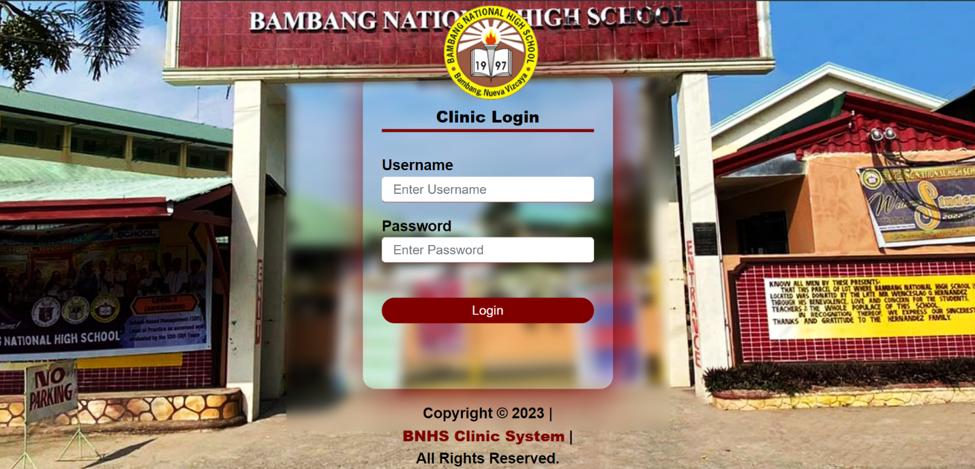

STEP 1

STEP 2

*Figure 6.* How to Login

Step 1: Enter your username and password.

Step 2: Click “Login” button to proceed to the clinic dashboard page.

**OFFICIAL CO-CURRICULAR TRANSCRIPT**



|  |
| --- |
| **Name: Fabelico, Fitzfedrix E.** |
| Address: Buag, Bambang, Nueva Vizcaya 3702 |
| Email address: drixzfabelico@gmail.com |
| Contact number: 09533005300 |

|  |  |
| --- | --- |
| **PERSONAL INFORMATION** | |
| Age: 22 | Date of Birth: June 4, 2000 |
| Civil Status: Single | Place of Birth: Bambang, Nueva Vizcaya |
| Religion: Roman Catholic | Father’s name: Fitzgerald L. Fabelico  Mother’s name: Livinia E. Fabelico |

**EDUCATIONAL BACKGROUND**

|  |  |  |  |  |
| --- | --- | --- | --- | --- |
|  | Name of school | | Date completed | |
| Tertiary | Saint Mary’s University, Bayombong, N.V. | | August 2018 – Current | |
| Secondary | Saint Mary’s University, Bayombong, N.V. | | August 2016 – May 2018 | |
| Elementary | Saint Catherine’s School, Bambang N.V. | | June 2006 – April 2012 | |
| **MARIAN CORE VALUES**  **EXCELLENCE** (It refers to academic/ scholastic accomplishments and involvement in non-academic activities wherein the students develop knowledge, competencies, and skills) | | | | |
| **Award** | | **Event / Competition** | | **Date** |
|  | |  | |  |

|  |  |  |
| --- | --- | --- |
| **Involvement** | **Seminar / Convention** | **Date** |
| Participant Network Security and Cryptography 11/20/19  Participant Y4IT (Youth for IT) 8/20/21  **INNOVATION** (It refers to creative output such as research papers, capstone projects, systems developed, and students’ involvement in literary, arts and visual performances) | | |

|  |  |  |
| --- | --- | --- |
| **COMMUNION** (It refers to students’ involvement in school and community activities and leadership / trainings attended / conducted) | | |
| 1. **SCHOOL INVOLVEMENT** | | |
| **Designation** | **Organization** | **Date** |
|  |  |  |
| 1. **LEADERSHIP TRAININGS/SEMINARS** | | |
| **Involvement** | **Seminar / Training** | **Date** |

|  |  |  |
| --- | --- | --- |
| **PASSION FOR CHRIST’S MISSION** (It refers to students’ involvement in spiritual and pastoral activities) | | |
| **Involvement** | **Event** | **Date** |
| Participant Year of the Youth 2019 2019  **TECHNICAL SKILLS / COMPETENCIES** | | |

* Basic Knowledge about Android Studio, Visual Studio and Adobe Xd.
* Basic Knowledge of WonderShare Filmora, Adobe PhotoShop, Video editing and Photo editing.
* Knowledgeable in SQL, Java, HTML and XML.

**OFFICIAL CO-CURRICULAR TRANSCRIPT**

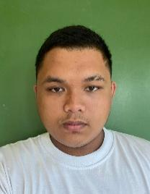

|  |
| --- |
| **Name: Olpindo, Brent Joshua A.** |
| Bascaran, Solano, Nueva Vizcaya |
| Email address: brentolpindo@gmail.com |
| Contact number: 09503390225 |

|  |  |
| --- | --- |
| **PERSONAL INFORMATION** | |
| Age: 22 | Date of Birth: July 31, 2000 |
| Civil Status: Single | Place of Birth: Bayombong, Nueva Vizcaya |
| Religion: Roman Catholic | Father’s name: Jehova L. Olpindo  Mother’s name: Anna Liza A. Olpindo |

**EDUCATIONAL BACKGROUND**

|  |  |  |  |  |
| --- | --- | --- | --- | --- |
|  | Name of school | | Date completed | |
| Tertiary | Saint Mary’s University, Bayombong, N.V. | | August 2019 – Current | |
| Secondary | Saint Mary’s University, Bayombong, N.V. | | August 2016 – May 2018 | |
| Elementary | Isaiah Christian Academy, Solano, N.V. | | June 2006 – April 2012 | |
| **MARIAN CORE VALUES**  **EXCELLENCE** (It refers to academic/ scholastic accomplishments and involvement in non-academic activities wherein the students develop knowledge, competencies, and skills) | | | | |
| **Award** | | **Event / Competition** | | **Date** |
|  | |  | |  |

|  |  |  |
| --- | --- | --- |
| **Involvement** | **Seminar / Convention** | **Date** |
| **INNOVATION** (It refers to creative output such as research papers, capstone projects, systems developed, and students’ involvement in literary, arts and visual performances) | | |

|  |  |  |
| --- | --- | --- |
| **COMMUNION** (It refers to students’ involvement in school and community activities and leadership / trainings attended / conducted) | | |
| 1. **SCHOOL INVOLVEMENT** | | |
| **Designation**  Business Manager | **Organization**  MICRO | **Date**  S.Y. 2021-2022 |
|  |  |  |
| 1. **LEADERSHIP TRAININGS/SEMINARS** | | |
| **Involvement** | **Seminar / Training** | **Date** |

|  |  |  |
| --- | --- | --- |
| **PASSION FOR CHRIST’S MISSION** (It refers to students’ involvement in spiritual and pastoral activities) | | |
| **Involvement** | **Event** | **Date** |
| **TECHNICAL SKILLS / COMPETENCIES** | | |

* Basic Knowledge about Android Studio, Visual Studio and Adobe Xd.
* Knowledgeable in SQL, Java, HTML and XML.